 | Module MOD003218: Operating Systems  Assignment Semester 2 2022/23  Aadithyan Prakash  SID=2191136

MENU

Part 1…………………………………………………………………………………………………………………………………………….2
MS-DOS…………………………………………………………………………………………………………………………………2
BASH………………………………………………………………………………………………………………………………………6
Part 2……………………………………………………………………………………………………………………………………………..11
Question 1……………………………………………………………………………………………………………………………..11
Question 2……………………………………………………………………………………………………………………………..11
Question 3……………………………………………………………………………………………………………………………….12
Question 4……………………………………………………………………………………………………………………………….12
Question 5………………………………………………………………………………………………………………………………13
References……………………………………………………………………………………………………………………………………….14

INTRODUCTION
An operating system is a collection of computer programs designed to act as an intermediary between the computer hardware and the user such that each can “understand “ the other.
JCL[Job Control Language] are text files which look like computer programs but are generally used, not to write user applications but to automate administration tasks the system or system administrator needs to do.

PART 1

MSDOS

Question:
Write a JCL script in either MS-DOS or bash (or both if you wish, see later) which reads in a text file (as a command line parameter) with source and destination folders to perform copy files.

Answer:
,,,,,,,,,,,,,,,,,,,,,,,,,,,,,,,,,,,,,,,,,,,,,,,,,,,,,,,,,,,,,,,,,,,,,,,,,,,,,,,,,,,,,,,,,,,,,,,,,,,,,,,,,,,,,,,,,,,,,,,,,,,,,,,,,,,,,,,,,,,,,,,,,,,,,,
@echo off
rem asks the user to enter the source folder they want to copy from
set /p source="Please enter the source folder you would like to copy from: "
rem ask the user to enter the destination folder they want to copy to
set /p destination="Please enter the destination folder you would like to copy to: "
echo Copying files from %source% to %destination%...
rem Check if the source folder exists
if not exist "%source%" (
echo Source folder does not exist.
pause
exit /b
)
rem check if the destination folder exists
if exist "%destination%" (
rem if the destination folder exists,ask the user to confirm if they want to overwrite the files
set /p overwrite="Destination folder already exists. Overwrite? (y/n): "
if /i "%overwrite%"=="n" (
echo Copy operation cancelled by user.
pause
exit /b
)
)
rem use xcopy command to copy files from the source folder to destination folder
xcopy /E /I /Y "%source%" "%destination%"
rem check if the copy operation was successful
if %ERRORLEVEL% EQU 0 (
echo Copy operation completed successfully.
) else (
echo An error occurred during the copy operation.
)
pause
exit /b
‘’’’’’’’’’’’’’’’’’’’’’’’’’’’’’’’’’’’’’’’’’’’’’’’’’’’’’’’’’’’’’’’’’’’’’’’’’’’’’’’’’’’’’’’’’’’’’’’’’’’’’’’’’’’’’’’’’’’’’’’’’’’’’’’’’’’’’’’’’’’’’’’’’’’’’’’’’’’’’’’’’’’
When @echo off is used it turns off the display of commands in screen.

set /p source="Please enter the source folder you would like to copy from: "
set /p destination="Please enter the destination folder you would like to copy to: "
It will allow the user to enter the source and destination folder.

echo Copying files from %source% to %destination%...
This will display a message on the screen that the values were entered.

if not exist "%source%" (
echo Source folder does not exist.
pause
exit /b
)
This checks whether the source folder exists or not and if it does not exist then the script exists with an error code using the ‘exit/b’ command

if exist "%destination%" (
set /p overwrite="Destination folder already exists. Overwrite? (y/n): "
if /i "%overwrite%"=="n" (
echo Copy operation cancelled by user.
pause
exit /b
)
)
This checks whether the destination folder exists and if it does exists then the user is prompted whether they what to overwrite it or not? If the answer is no then it displays a message in the screen indicating that the copy task was cancelled and the script exits

xcopy /E /I /Y "%source%" "%destination%"

xcopy is command used to copy, /E ensures all subfolders were copied, /I treats the destination as a directory if it does not exists, /Y is used to supress the prompting to confirm whether you want to overwrite the destination file or not.

if %ERRORLEVEL% EQU 0 (
echo Copy operation completed successfully.
) else (
echo An error occurred during the copy operation.
)
If copy operation was successfull it exits and displays it was successful or it says error. Pause command is used to pause script.

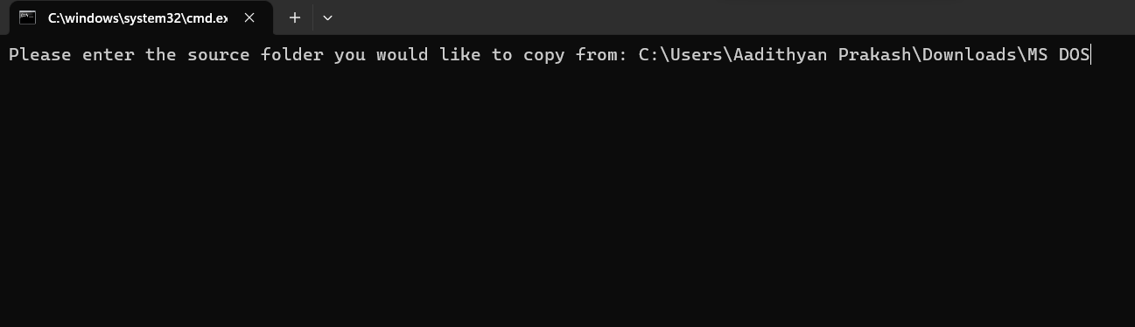
Fig.1
First it will ask the user to enter the source path . ( as in fig.1).

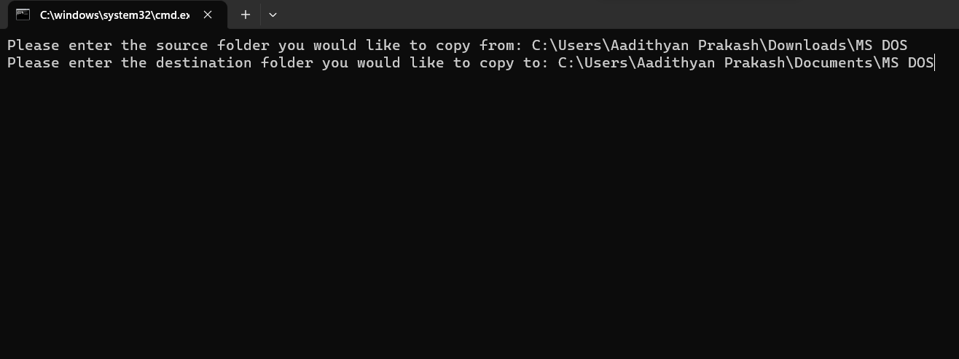
Fig.2
Then it will ask the user to enter the destination folder (as in fig.2).
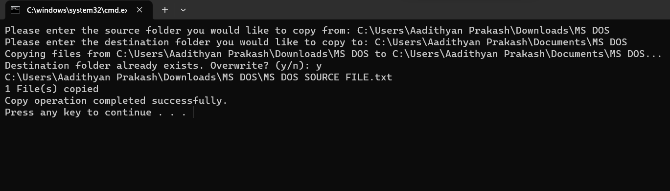
Fig.3
If the source folder and the destination folder the user entered is correct then the code will copy the files in the source folder to the destination folder .( as in fig.3).
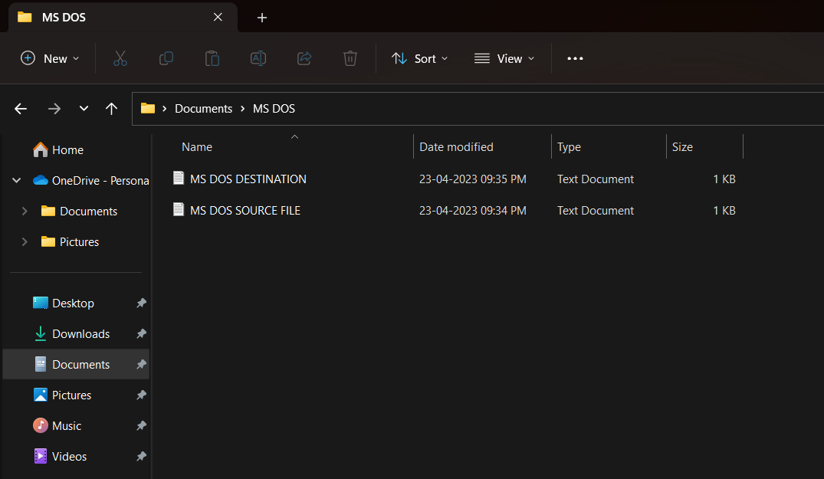
fig.4
As you can see the file has been copied to the destination folder( as shown in fig.4).
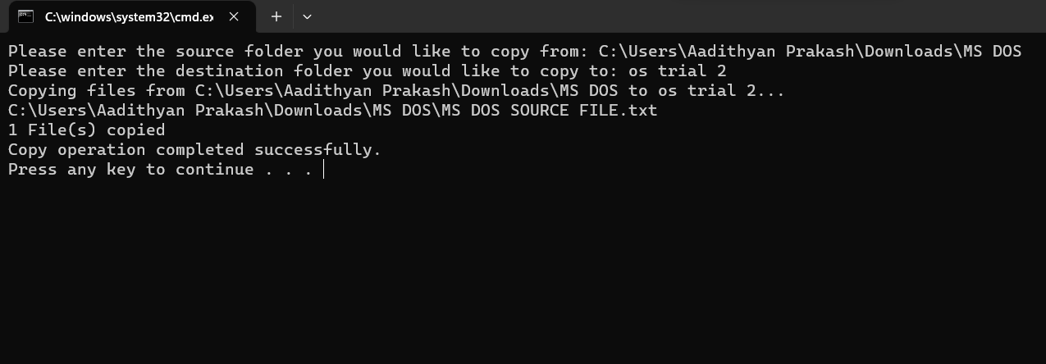
Fig.5
If there is no destination folder then it will create a new folder with the destination folder name you gave and paste it in that folder. (as shown in fig.5).

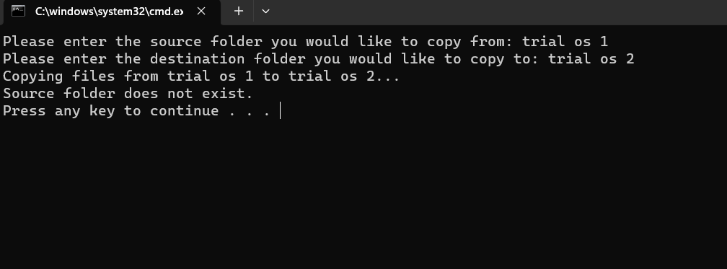
Fig.6
If the source folder the user entered is wrong or does not exist then the program will show ‘Source folder does not exit’ (As shown in Fig.6).

BASH

Question:
Write a JCL script in either MS-DOS or bash (or both if you wish, see later) which reads in a text file (as a command line parameter) with source and destination folders to perform copy files.
Answer:
,,,,,,,,,,,,,,,,,,,,,,,,,,,,,,,,,,,,,,,,,,,,,,,,,,,,,,,,,,,,,,,,,,,,,,,,,,,,,,,,,,,,,,,,,,,,,,,,,,,,,,,,,,,,,,,,,,,,,,,,,,,,,,,,,,,,,,,,,,,,,,,,,,,,,,
#!/bin/bash

#operation used to copy file function (copy_file).
function copy_files() {
source=$1
destination=$2

#This is to check whether the source folder exists or not.
if [ ! -d $source ]; then
echo "Source folder $source does not exist!"
return
fi

#This is to check whether the source folder exists or not.
if [ -d $destination ]; then
read -p "Destination folder $destination already exists. Overwrite? (y/n): " overwrite
if [ $overwrite != "y" ]; then
echo "Copy task cancelled."
return
fi
rm -r $destination
fi

#This is to copy files from the source to destination.
cp -r $source $destination
echo "Files copied from $ source to $destination"
}

#This is to check whether the command line parameter is given or not.
if [ $# -eq 1 ]; then
#This is to read the input from the file.
input_file=$1

#This is to check whether the input file exists or not.
if [ ! -f $input_file ]; then
echo "Input file $input_file does not exist!"
exit 1
fi
#This is to loop through each line in the input file.
while read line; do
#This is to split the line into source and destination folder paths.
src=$(echo $line | cut -d' ' -f1)
dest=$(echo $line | cut -d' ' -f2)

copy_files $source $destination
done < $input_file
else
# This is to prompt the user for the source and destination files.
read -p "Enter source folder path: " source
read -p "Enter destination folder path: " destination

copy_files $source $destination
fi
,,,,,,,,,,,,,,,,,,,,,,,,,,,,,,,,,,,,,,,,,,,,,,,,,,,,,,,,,,,,,,,,,,,,,,,,,,,,,,,,,,,,,,,,,,,,,,,,,,,,,,,,,,,,,,,,,,,,,,,,,,,,,,,,,,,,,,,,,,,,,,,,,,,,,,

#!/bin/bash is used to specify that the script should run using the bash shell.
function copy_files() { is the function used to copy files

source=$1 assigns first line command to source
destination=$2 assigns second line command argument to destination

if [ ! -d $source ]; then
echo "Source folder $source does not exist!"
return
fi
this checks whether the source directory exists or not , and if it does not exist then it outputs an error message and returns without doing anything.

if [ -d $destination ]; then
read -p "Destination folder $destination already exists. Overwrite? (y/n): " overwrite
if [ $overwrite != "y" ]; then
echo "Copy task cancelled."
return
fi
rm -r $destination
fi
this checks whether the destination directory exists or not . If it exists it prompts the user whether they want to overwrite the existing directory or not. If the answer is no then the script outputs a message and returns without doing anything.

cp -r $source $destination
echo "Files copied from $source to $destination"
This copies the files in source directory to destination directory and if the copy task is successful, it prints a message.
if [ $# -eq 1 ]; then
input_file=$1
if [ ! -f $input_file ]; then
echo "Input file $input_file does not exist!"
exit 1
fi
while read line; do
src=$(echo $line | cut -d' ' -f1)
dest=$(echo $line | cut -d' ' -f2)
copy_files $source $destination
done < $input_file
else
read -p "Enter source folder path: " source
read -p "Enter destination folder path: " destination
copy_files $source $destination
fi
The code checks whether the script has atleast one command line argument. The script then checks whether the file exists and if it does not exist it prints an error message and exits. If it exists then the script will read the source and destination folder paths. It then calls the copy_files function.
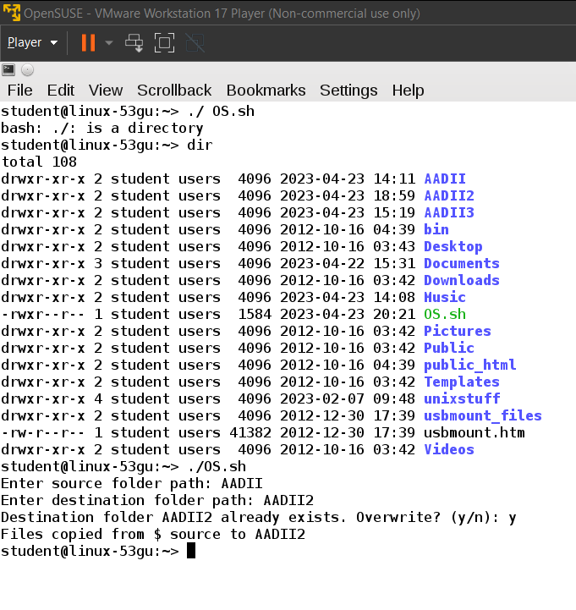
Fig.7
./ command is used to open the directory OS.sh
The script then asks the user for the source folder path.
Then the script asks the user for the destination folder path.
If the destination folder exists then the script will ask the user whether they want to overwrite the folder or not. If it does not exists then it will create a new directory and save it .
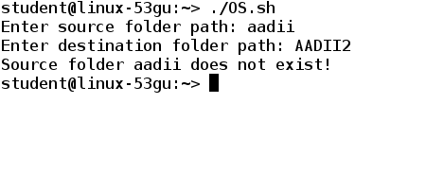
Fig 8
If the source folder path entered by the user is wrong then the script will print that the source folder does not exist.
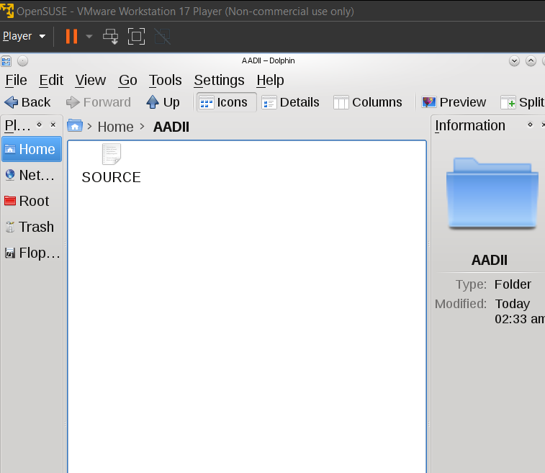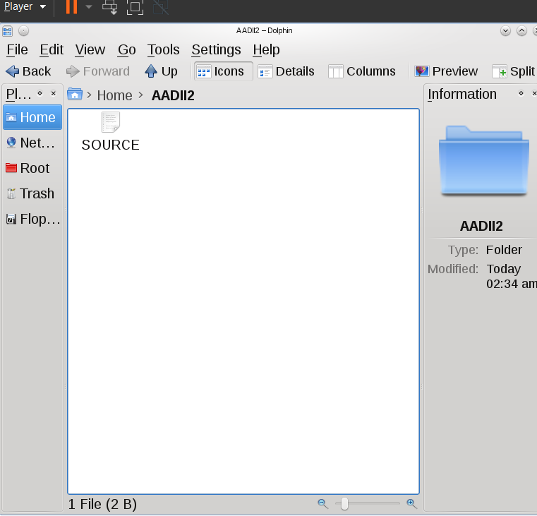
Fig.9 fig.10
The source txt file in AADII got copied to the file AADII2 (as in fig.9 and fig.10)

Part 2

Question 1

What is meant by starvation in process management? What will be the consequence of starvation? How can starvation be avoided?
Answer:
Starvation is the term which is used in process management to help describe a situation in which a process is unable to run even when it is prepared to do. When the operating system which adapts a scheduling mechanism that favours other processes over the process that are hungry, it might result in which the process might be unable to receive the resources it needs to function.
As a result of starvation, a process may not be able to finish its task, resulting in a deteriorated system's performance, delays, and lost productivity. System failure or deadlock may occur if a crucial process is starved of resources.
Operating systems often use scheduling algorithms that give processes a priority ranking based on their priority level, execution history, and other parameters in order to prevent starvation. To guarantee that every process has an equal opportunity to run, for instance, some scheduling algorithms may use round-robin or lottery-based techniques. Additionally, in order to minimise starvation of lengthy processes, operating systems may employ strategies like ageing, in which a process' priority level rises with time.

Question 2

In the context of memory management, what is a page fault? Describe the actions that follow after a page fault occurs?

Answer:

A page fault in memory management happens when a programme tries to access a memory page that is either not currently available in physical memory or is not currently mapped to physical memory. This may occur if the page has not yet been allocated or has been swapped out to disc.
When a page failure happens, the operating system pauses the application and looks for the needed page in secondary storage (such a hard drive or solid-state drive). The page is then loaded into physical memory and its new position is reflected in the page table after it has been located. A page fault-causing instruction is continued after control is handed back to the programme.

Question 3

My email system gives me a choice of POP3 or IMAP. I am currently using POP3. Why might I want to switch to IMAP? Explain both POP3 and IMAP and give justifications whether I should switch to IMAP.
Answer:

POP3 (Post Office Protocol version 3) and IMAP (Internet Message Access Protocol) are protocols which helps for accessing email on the mail server. They Both have the same base function but works in different ways
The POP3 protocol downloads the email from the server to the user device and will delete the original copy of the email from the server. This shows that when we view the email from POP3 client then we will make a local duplicate of the email in our device. The emails might not be synchronised across other devices and cannot view the emails until they are downloaded.
Whereas in IMAP, we can access our emails directly on the server. We can also access our email messages from many devices and it will sync between them all. IMAP also has the capacity to store and search our emails directly on the server.
Reasons that you want to switch to IMAP-
- It would allow us to access your email from multiple devices.
- It will backup our emails.
- It will also help us to synchronize our email across all our devices.
In general, you could switch to IMAP if you need to access your email from different devices or if you wish to effortlessly backup your email. However, POP3 might be enough if you only use one device to view your email and you don't need to save your messages.

Question 4

In an Operating system what does it mean when a computer is said to be “trashing”? How can it be prevented?

Answer:
When system spend more valuable time and resources on virtual machine than on actual tasks allowed by the uaser is known as thrashing. The main reason behind it is that system does not have enough ram to keep with the one or more programs running in the background.
Methods to prevent trashing:
- The easiest way is to add more RAM to the system
- Close all unnecessary programs
- Using a more efficient operating system
- Using a SSD instead of traditional hard drives
- You could also try limiting the number of programs running

Question 5

In the bash shell what does the ampersand (“&”) symbol mean when used in a command? If I used an & in a command why might I need to use the command “ps”?

Answer:

The symbol used to run a command in the background in the bash shell is called the ambersand symbol(“&”).When the command is running in the background it won’t hold up the terminal and allows us to continue to use it for other tasks.
If I use the ambersand symbol in a command , I may need to use the ‘ps’ command to find the status of the background process. The ‘ps’ command will display information on the current running process in my system. You could also use the command ‘ps -ef | grep <process_name>’ to see the list of running background processes.

References

- Chapter 5 of the book “ Process Synchronization” , it explains starvation , its causes and consequences in detail . It also shows many techniques for avoiding starvation. The section on starvation can be found in pages 211-214. (Question 1)

- Chapter 9 of the book Operating Systems Concepts( 10th ed) by Silbersachatz.The information on the page faults in memory management can be found on pages 402-405.(Question 2 )

- Chapter 13 of the book Operating System Concepts (10th ed) . The information on email protocols can be found on pages 549-590.(Question 3)

- Anderson, T., & Dahlin, M. (2014). Operating Systems: Principles and Practice (2nd ed.). Recursive Books. Chapter 17, pages 723-738.(Question 4)

- “Learning the bash Shell: Unix Shell Programming" by Cameron Newham and Bill Rosenblatt explains the use of the ampersand symbol in bash commands on pages 42-43.(Question 5)

